The Well Developed Classroom Blog: Everyday Differentiated Instruction:
Using Supports and Extensions to Increase Student Achievement

"I never teach my pupils; I only attempt to provide the conditions in which they can learn."
Albert Einstein

- What is Differentiated Instruction?
Differentiated Instruction is the thoughtful response to diversity in the classroom.

Similar to Einstein’s description above, differentiate instruction is the result when teachers provide conditions to ensure effective and efficient learning for all students.

Differentiated Instruction begins when teachers perceive student diversity that will either strengthen or pose challenges for effective and efficient learning. Teachers respond through differentiated instruction that will either leverage student strengths to facilitate learning or eliminate a challenge that would impede learning.

Examples of diverse student strengths that can facilitate learning:

- multiple perspectives
- variety of interests
- ways of learning
- communication skills: drawing, building, speaking, moving, writing, speaking multiple languages
- leader and supporter preferences
- logical and creative thinking
- spatial and sequential organization skills

Examples of diverse challenges that often impede learning:

- low reading levels
- missing background knowledge
- unknown vocabulary
- needed sequential thinking skills
- weak basic skills (math, reading, writing)
- misconceptions or missing procedural knowledge
- unfamiliar interpersonal skills

- What is “Everyday” Differentiated Instruction?
This sequence of efforts to perceive diversity and thoughtfully respond through instruction creates a formative assessment cycle. Everyday differentiated instruction is usually based on data from small focused assessments. These assessments are designed to make visible strengths and challenges so that teachers can provide precise instruction for all learners and students understand why they are working on learning tasks. Most differentiated instructional responses should be based in classroom routines and structures that are known to students and easily sustained by teachers. The more precise the teacher’s response to student instructional strengths and needs the more likely the differentiated instruction will lead to both efficient and effective learning.

Differentiated instruction is not meant to be an “event” that is planned for over weeks at time, to be delivered once, for an observation or a Quality Review. If the practices of DI are not embedded in the regular planning, teaching, and assessing cycle, then it is not an easily sustainable routine. Naturally, learning how to integrate everyday differentiation into instruction takes time, support, and practice. This said, not every moment of every lesson should necessarily be differentiated. It is important to understand the deeper goals of DI to be able to understand when, each day, it best to use certain strategies.

Goals of Differentiated Instruction
Differentiated Instruction has these desired results:

- DI ensures that each member of the learning community is engaged, valued, and stretched.

- DI is precise instruction that results in efficient and effective learning within the established curriculum.

- DI is part of daily classroom culture focused on developing relationships among people, building curricular understanding, knowledge, and skills and valuing diversity.

- Why is this important?
“We are not all the same; we do not all have the same kinds of minds (that is, we are not all distinct points on a single bell curve); and education works most effectively if these differences are taken into account rather than denied or ignored.”
Gardner H. (1999) Intelligence Reframed. New York: Basic Books. (91)

Howard Gardner draws our attention to the diversity among learners that is always present in every classroom. When diversity is ignored in the classroom some students are learning while other students are waiting for an opportunity to engage in learning. When the learning experience does not fit the learning needs of the students then valuable learning time at school is wasted. However, when diversity is recognized through thoughtful precise instruction then all students are engaged and stretched toward reaching learning goals.

Differentiated Instruction is an important part of effective and efficient teaching and learning. Differentiated Instruction is effective when students and teachers are working toward explicit learning goals and teachers have created learning opportunities that support and extend student independence in pursuing their own growth. Differentiated Instruction is efficient because all students are moving toward reaching learning goals all of the time. Teachers interested in having more time to teach and more time for students to learn rely on differentiated instruction as a daily approach to teaching.

- What does this look like?

The perception of student diversity and teacher response
is continuous throughout lessons.
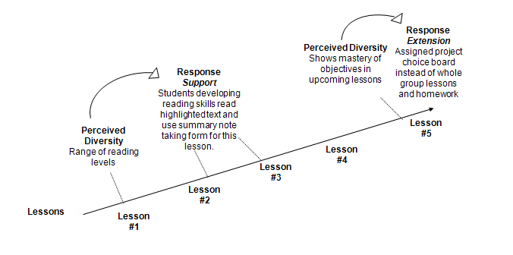

The figure above is an example of what differentiated instruction looks like in the classroom. We see a series of forward moving lessons where the teacher at times perceives a type of diversity among the students that poses a challenge to all students moving forward. So, the teacher responds by adding supports in lessons #2 and #3 and an extension in lesson #5. The support in lessons #2 and #3 is something that will enable students to acquire new content without the challenge getting in the way. In this case, the teacher noticed in lesson #1 that some students are reading below the grade level of the text assigned in lesson #2. The teacher uses differentiated instruction to meet three instructional goals: 1. All students need to be familiar with this text, 2. Logistically, the students need to finish reading all at about the same time so that the class can have a discussion, and 3. The students need to comprehend the most important content from the text to participate in the discussion. Therefore, the teacher gives the students who are struggling with the reading a highlighted text with a summary note taking form. This support will enable the students to learn the new content without as much struggle with comprehension. The teachers will focus on comprehension at another time most likely in a lesson where the topic is a review. In lesson #4, it looks like there was an assessment perhaps a quiz or project that enabled the teacher to determine that some students had mastered the objectives being taught in lesson #5. Rather than students sitting through lesson #5 when they have shown mastery of the objectives, the teacher offers students a choice board of assignments that review and extend the learning goals of lesson #5. Students who do not need lesson #5 continue their learning through the choice board while the rest of the class completes lesson #5.

Four ways to respond to diversity through Differentiated Instruction
Teachers typically use three instructional methods to respond to the learning needs of students. Supports and extensions are tools and strategies that enable teachers to move all students toward common learning goals. Remediation is different than supports and extensions because remediation usually moves some students toward achieving goals that were taught in previous units or in different courses or grades. And so, students receiving remediation may have different learning goals.

Remediation/Acceleration – continue to work on objectives from previous units that have not been mastered while moving forward into the next unit. Seek to develop missing skills, knowledge, and understanding that are necessary to progress in learning.

Supports – provide structures that enable students to learn new content without being hampered by learning challenges. The learning challenges will be addressed in another lesson. Often learning challenges are addresses when the content of the lesson is a review for the student. When the content or material of the lesson is new to the student, providing supports for learning challenges enables the student to focus on acquiring the new information, skills, and understanding.

Extensions – provide stretch for students who have mastered the objectives being taught in a lesson.

Multiple Pathways - provide multiple means of representation of the ideas, processes for learning, and performances to demonstrate learning.

- What does supports, extensions, and remediation look like in the flow of teaching and learning?

There are many teachers respond through differentiated instruction to the diverse learning needs of students. The four examples that follow highlight structures that are commonly used to increase precision in teaching resulting in efficient and effective learning.
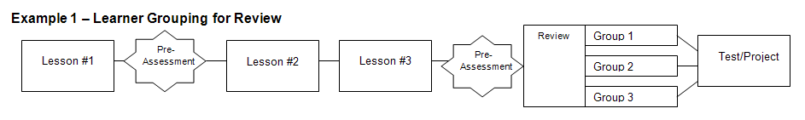
A typical “whole class” review or “going over” problems or homework with the entire class together often results in very few opportunities for students to think. Often, time does not permit the teacher to go over every problem so students end up taking the problems home to study that they do not understand. One way to avoid these problems is to group students for review by the learning goals that they need to review. In this example, all student receive the same review assignment, but students will be grouped by the learning goal that the need to review. The teacher will visit each group during the review lesson to share a mini lesson on the needed learning goal and review assignments related to the goal. Students continue to work on the review assignment until the teacher comes to their group.

What if my room is too small to move students into different groups?

When there isn’t time to move students into groups or the room is too small then there are many options other than moving students into different groups.

Possible Options:
- Teacher circulates: Teachers write different independent practice assignments related to specific learning goals on the board. Students are assigned or choose the assignment that they need to work on and begin while staying in their seats. There will be students working on different assignments in each group. The teacher circulates among the students to assist and offer feedback.

- Teacher gathers small groups of students at a table or area for short mini lessons: All students begin working on independent work at their normal seats. The teacher conducts 15 minute mini-lessons reviewing different topics at a table or area of the room. At the beginning of each mini-lesson, the teacher calls out the topic and students needing to review that topic join the teacher at a table in an area of the room. Students not involved in the mini-lesson continue to work. In between the mini lessons, the teacher circulates around the room assisting students with independent work.

There are ways to work within space and time constraints. Teachers should first decide how students will learn most efficiently and effectively and then devise lesson structures that are sustainable given the space and time constraints. For example, once students are taught the expectations of completing independent practice while mini-lessons are being conducted then this lesson structure can be used at any time when some students need review, remediation, and/or extensions during a lesson.

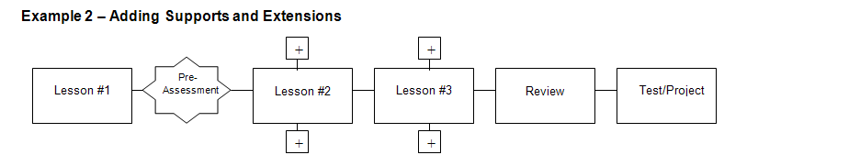

Example 2 shows a teacher using a pre-assessment to assign supports and extensions for Lessons #2 and #3 then everyone completes the Review and Test/Project. The pre-assessment could be an exit card checking understanding of Lesson #1, a homework assignment from Lesson #1 or a Do Now assignment at the beginning of Lesson #2. The Supports and Extensions are probably different learning materials or activities related to an essential learning goal for the unit. The supports and extensions might include: different types and levels of reading material on a given topic, problems or materials that review a previous unit as supports and problems or materials that provide a different perspective or application of the topic under study as extensions. The teacher is using the same type of supports and extensions for two consecutive lessons. This enables the learners to practice using the supports or extensions and save time in teaching a new routine for the classroom. The supports and extensions in this example stay focused on accomplishing a common goal for all students that will measured through a test/project. Therefore, it is likely that the expected homework or product for Lessons #2 and #3 will be the same for all students. For example, students may read different texts but they will answer the same five questions with written responses or students may use different graphic organizers to complete a set of problems, but the set of problems would be the same for all students.

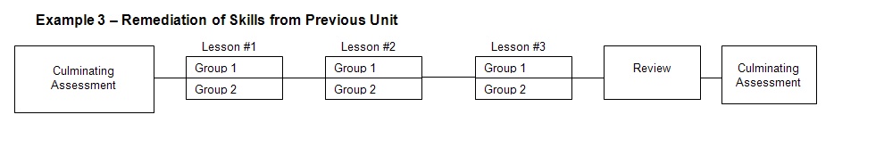
Example 3 shows a Culminating Assessment from the previous unit serving as a pre-assessment for Lesson #1 of a new unit. Here it appears that the Culminating Assessment revealed that some students need remediation or a review of the previous unit while going forward with the next unit. In this case the teacher divides the students into two groups for three lessons. Group 1 might be both reviewing the previous unit and practicing missing skills while learning the next unit. Group 2 may be moving on to the next unit and completing a related project. The teacher may have a co-teacher who is working with one group or the teacher may organize the class so that Group 1 is doing independent practice or partner feedback/activities while he/she is teaching Group 2 and then the teacher switches his/her focus to the other group. The teacher and students will know this differentiation was effective if all students succeed on the Culminating Assessment. In this format, the homework assignments for Lessons #1, #2, and #3 are often different.

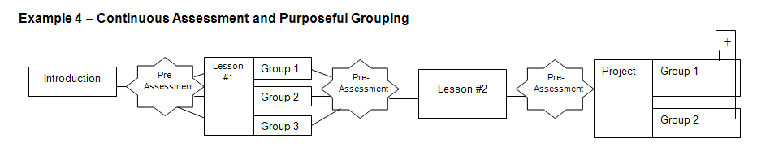
Example 4 shows how differentiated instruction becomes part of the everyday flow of teaching and learning. After the Introduction a Pre-Assessment shows that students vary in a way that is important to address through Lesson #1. Perhaps students have different interests in the topic and they will be grouped by interest for Lesson #1. Some students may have misunderstandings of concepts or missing skills that will be needed for Lesson #2. Or students may have different previous learning experiences with the topic that if reviewed in Lesson #1 will make acquiring new information in Lesson #2 easier. There are many different reasons why a teacher may group students in this way following a pre-assessment.

In Social Studies the groups could be studying deeply the people, places, or events related to a topic and then regrouping students for Lesson #2 to share that background information as everyone learns more about the topic together.

In Math, students might be grouped by ability for Lesson #1 reviewing basic skills with one group related to the topic under study, exploring the topic with another group, and extending the topic with a more complex application or comparing the topic to another topic for students who have already mastered the skills and don’t need an additional lesson.

In Science class each group may have a different research question for the same experiment.
In an English Language Arts class the groups may be reading texts on different reading levels related to a common theme.

The key here is the differentiation in Lesson #1 enables everyone to engage in Lesson #2. The importance of assessment is highlighted in this example. After Lesson #1 the teacher checks to make sure that the differentiated instruction was successful with a Pre-Assessment before starting Lesson #2. Then before the Project there is another Pre-Assessment. This assessment may determine interest. The ongoing nature of perceiving student diversity through assessment and then responding to learning needs through differentiated instruction is clear in this flow of teaching and learning.

Notice that the teacher has to provide supports for both Group 1 and Group 2 in the final project. Although students are grouped, there is a range of abilities in the groups and some students will need supports to complete the project. In this case, the demonstration of content knowledge is more important than the type of product students are completing because there are two different projects. For example, some students may be writing a script for a movie while others are making a museum exhibit. Or some students may be making a 3-D model while other students are drawing a concept map. It appears that the teacher may have grouped students by interest or strength to allow students to demonstrate their skills and knowledge. This type of differentiation is useful when revealing content knowledge is the priority for an assignment. This type of differentiation is not recommended if there is a common expectation for a final product that all students must complete, for example, preparing for a standardized test or essay.

These four examples explore differentiated instruction across a series of lessons. The examples begin to show how differentiated instruction is precise and results in effective and efficient learning. Use the additional examples in the resources section to find more ideas on how to use differentiated instruction daily. Post questions about differentiated instruction to receive responses specific to your classroom. Future blogs will address what differentiated instruction looks like within a single lesson and management techniques for differentiated instruction with large class sizes with a wide range of ability levels.

- More Resources:
Carol Tomlinson, University of Virginia. Tomlinson is the author of more than 200 articles, book chapters, books, and other professional development materials related to supporting teachers in creating responsive heterogeneous classrooms.
http://caroltomlinson.com/index.html

Tomlinson, C. (August 2005). Middle Ground. Differentiating Instruction: Why Bother? National Middle School Association, 9:1:12-14
http://www.nmsa.org/Publications/MiddleGround/August2005/Article1/tabid/339/Default.aspx

Johnson, B. (3/2/2009) Edutopi Blog. Differentiated Instruction Allows Students to Succeed.
http://www.edutopia.org/blog/differentiated-instruction-student-success
National Middle School Association: Short articles on DI addressing adolescence
http://www.nmsa.org/Publications/OnTarget/DifferentiatedInstruction/tabid/298/Default.aspx

